Cyrillic 1.1

Guide for Demonstration Disk
Cyrillic is a program for drawing family trees and managing pedigree data. It will be useful in hospitals and laboratories where genetic information is handled on a routine basis. The program is designed to work with IBM PCs or compatibles running Windows 3.1 with at least 2 Mb of RAM.
The demonstration version of the program on the accompanying disk is intended for evaluation purposes only and has several limitations.
• There is a limit of 15 persons in a family (the full application can handle up to 1,000 persons in a single family).
• The options to save or import files have been disabled.
• While a sample family can be printed, any printout will bear a legend explaining that it comes from a demonstration version of the program.
• The full program is accompanied by a manual of 200 pages. This brief guide introduces you to some of the key features and gives an indication of the program's scope, but it is intended to give you a glimpse rather than the full story.

Running the Cyrillic demonstration
To install the Cyrillic demonstration put the disk into your disk drive and in the Windows Program Manager, select the Run option from the File menu.
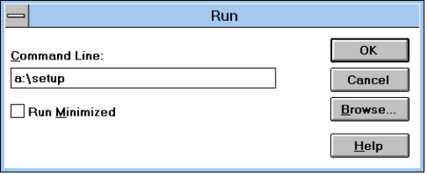
Type a:\setup in the dialog box and press <return>. You will be asked to confirm the directory for installation.
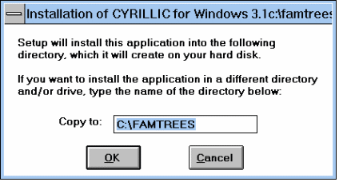
Press <return> to accept the default directory unless you wish to change it. The Cyrillic files will now be copied to your hard disk and a program group and icon will be created in the Windows Program Manager.
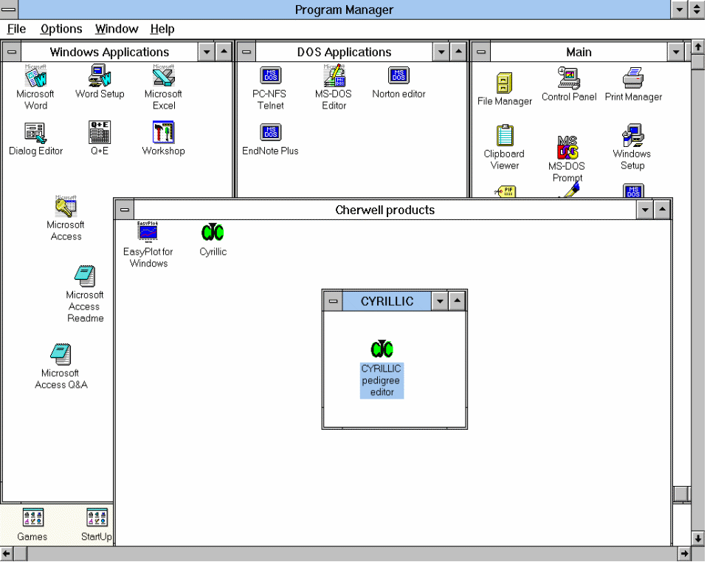
To run the demonstration program double click on the Cyrillic icon in the Windows Program Manager.
On your demonstration disk you will find a sample family 'DMDTest5.fam'. Select the file by choosing Open from the File menu. We will now guide you through some features of Cyrillic, but if you are confident with Windows programs why not explore the family yourself through the menus and the tool bar?

An Example Family
First, let us take a look at the menu system. The main headings: File, Edit, Options, Format, Input, Windows and Help group the principal functions of the program. Pull down the Edit menu and choose the Family Information option. You will see a dialog box with various items of information, for example that this is a family with Duchenne Muscular Dystrophy. Note that there are several areas in the dialog box where you can enter additional data.
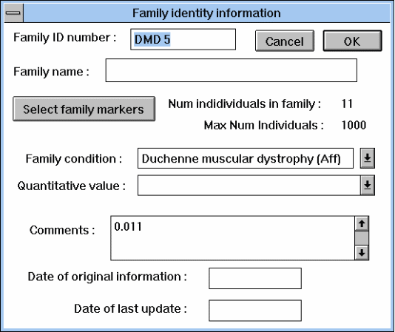
Now take a look at the Input/output and the Help options. If you experiment with the Windows menu you will find that you can change the tool bar into a floating palette which can be moved around your family tree. This is particularly useful when working with large families. Let us now use some of these tools.
First a general hint. Cyrillic works on the Object/Action principal. You select an individual or a group of individuals (the Object) and then you apply some Action to your selection. These actions are grouped in the menus and can also be invoked by clicking on the buttons in the tool bar. A second hint. You select an individual by pointing to it with the mouse and clicking with the left mouse button. If you want to select more than one individual, or an area from a family tree, hold the mouse button down and drag across your tree. Try this technique to select two or three individuals and then apply one of the tools to your selection by clicking the relevant button (try 'Marker', 'Spouse' or 'Ind Dat'). Notice that you cycle through the individuals you have selected and at each stage you can change data associated with the individuals by typing in the dialog boxes. As you work with Cyrillic you will find that there are plenty of short-cuts and some of these are mentioned on the menu.
You may nowlike to explore the family by using some of the tools. Select a married individual and click on the 'Spouse' button. You will find a 'Partnerships' dialog box, which you can use to change the 'kind of relationship' to 'separated' or 'divorced' (click in the check boxes). Notice what effect this has on the family tree. Now select an individual by clicking on the 'Ind dat' button.

Editing Patient Data
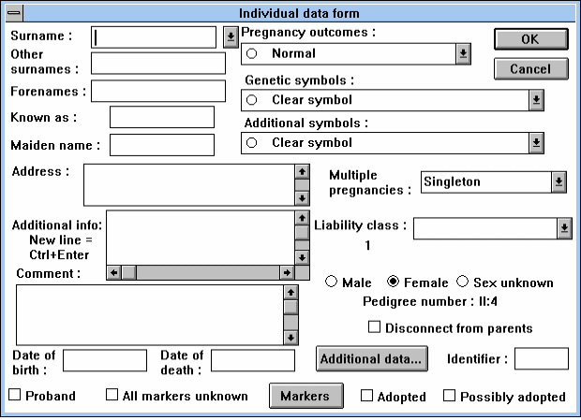
Change the Genetic Symbol representing the individual by selecting one from the scrollable list in the dialog box.
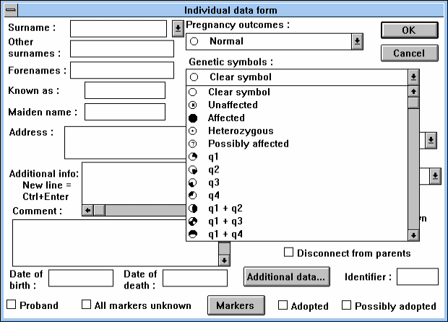
Next, select an individual and use the 'hide' or 'desc' buttons to see what you can do with these buttons. When you have performed an action with these tools you can use Display full family in the Options menu to return to the full family tree. Finally, try moving some of the individuals on the tree. Point to an individual with the mouse and drag the person, with the mouse button depressed, to a new location. You may also move a portion of the family tree by selecting some part of it and dragging the highlighted rectangle to the new location. The ability to move individuals or branches of the tree, by pointing and clicking is very handy when you need to make additions to a family. Before we draw a family from scratch try experimenting with some of the menu options and tools on the tool bar. Note that often additional features are available by using the right mouse button.
Now that you have taken a general look at the program, this section provides a step-by-step guide to producing a simple drawing. To draw a pedigree for a new family, select the New option from the File menu. If you are already working on a drawing, you will be asked whether you want to store this information. Since saving is disabled in this demonstration version of Cyrillic, select the No button in the dialog box. The screen will then be cleared and the 'Family identity information' dialog box will be displayed.

Drawing a new family
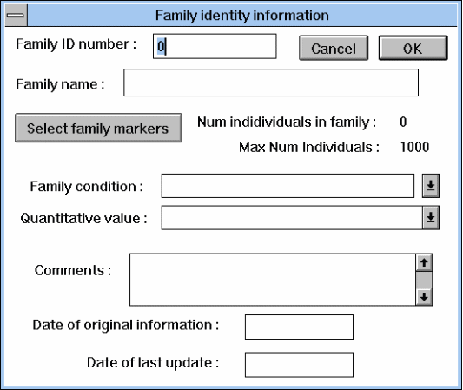
Once you have entered any information on the family, click on the OK button. Position the cursor where you want the first individual to appear on screen and click on the left mouse button for a female or the right button for a male. The 'Individual data form' dialog box appears.
Enter any information on the first individual and choose OK. The first symbol is displayed on screen. You can now enter family members related to this person. Position the cursor over the symbol and click the right mouse button. The 'Relationship of new individual' dialog box now appears.
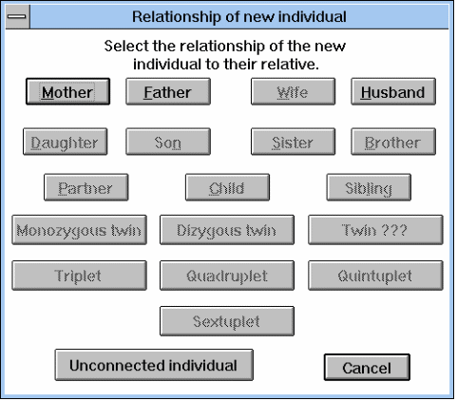
Click on the button for the appropriate relationship. This removes the dialog box and changes the cursor to indicate that you are entering a new relation. Position the cursor where you want the symbol to appear and click the left mouse button. You will now be presented with another 'Individual data form' dialog box for the new relation. Enter any relevant information and click on the OK button. The new symbol will be displayed on the screen with a line joining it to the first individual you entered.
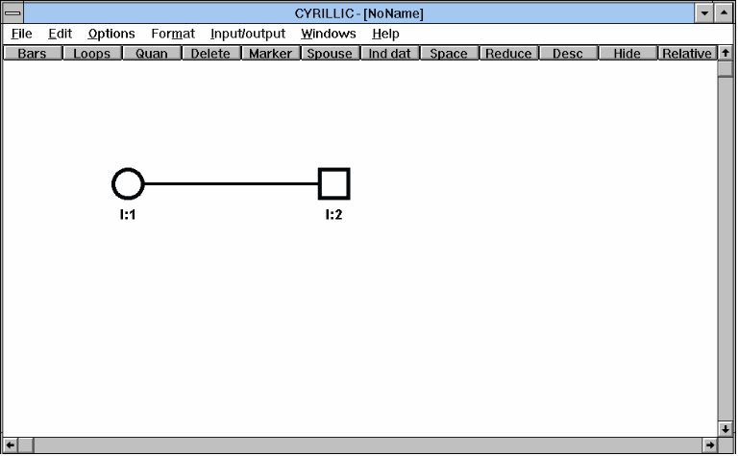
You can now draw the rest of the family using the same principles, remembering that the demonstration version allows a maximum of 15 individuals.
Cyrillic has far too many features to be described in detail in a short guide like this. Please experiment with the various options on the Format menu to discover how virtually every aspect of the drawing can be controlled to match your particular needs. Look also at the Edit menu options Edit Markers and Edit Diseases to examine the facilities Cyrillic offers for defining and recording disease and marker information.

Further explorations
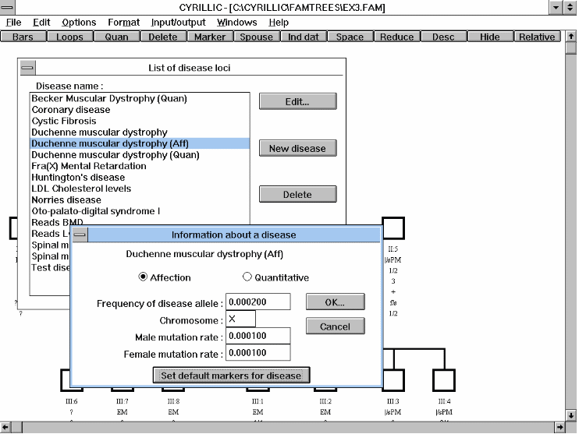

Cyrillic
We think you'll agree that Cyrillic is the most user-friendly and powerful pedigree drawing software on the market. We believe that Cyrillic and Microsoft Windows provide a winning combination of simplicity, publication-quality output, and powerful information management tools.

The ideal tool for creating family trees and managing genetic information
Cyrillic comes with a comprehensive user manual. This includes a tutorial, and detailed chapters on pedigree drawing, adding data, genetic markers, importing files, and outputting data to linkage analysis programs.
If you have any technical questions about Cyrillic ring Cherwell at any of the numbers below.
Don't you wish you were using Cyrillic today? Telephone, fax, or send your order direct to Cherwell Scientific at one of the following addresses.

Cherwell Scientific Publishing Ltd
Cherwell Scientific Publishing
c/o CHEM Research GmbH
Beethovenstraße 7 B
D-60325 Frankfurt
Germany

Tel: 069-7411114
Fax: 069-740496
The Magdalen Centre
Oxford Science Park
Oxford OX4 4GA
United Kingdom

Tel: +44 (0)1865 784800
Fax: +44 (0)1865 784801
Internet: csp@sable.ox.ac.uk

Cherwell Scientific Publishing, Inc
744 San Antonio Road
Palo Alto
CA 94303
Tel: (415) 852 0720
Fax: (415) 852 0723

